Supplementary figures and tables for:

**Can siphon holes be used for population assessments of intertidal soft-shell clams, *Mya arenaria*?**

Jeff C. Clements1,2*, Sarah Harrison1,2, Jillian Hunt1, Isabelle Brennan1,3, Heather L. Hunt2, Rémi Sonier1

**1** *Fisheries and Oceans Canada, Gulf Region, 343 Avenue Université, Moncton, NB E1C 9B6, Canada*

**2** *Department of Biological Sciences, University of New Brunswick, 100 Tucker Park Road, Saint John, NB E2L 4L5, Canada*

**3** *Moncton High School, 140 Longfellow Drive, Moncton, NB E1H 0G4, Canada*

**Figure S1.** Overhead images of the sediment surface at each of the four study sites.

**Figure S2.** Temperature (°C) time-series profiles at each of the four study sites. Each point represents the daily mean seawater temperature.



**Figure S3.** Relationships between siphon hole counts and total clam counts (i.e., clams both above and below 20 mm shell length) at each of the four sites for each observer. The red dashed line represents a 1:1 relationship between siphon hole count and clam count. Open circles represent excluded observations in which methods or conditions deviated from the norm.

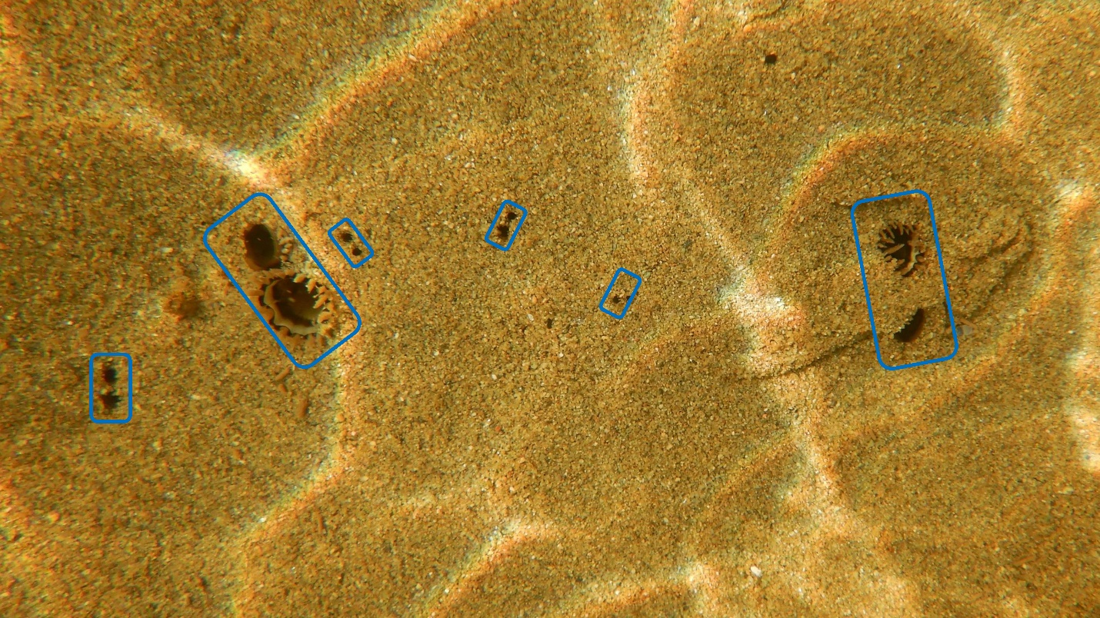

**Figure S4.** Overhead image of subtidal soft-shell clam siphon holes at the Kouchibouguac site. Visible siphons of individual clams are circled in blue. Note the defined structure of the two siphon channels for each individual clam. Note the high degree of definition of the two siphon channels for each clam.

**Table S1.** Results of ANOVA analysis for the effect of site on sediment grain size composition, % organic content, relative moisture content (%), and seawater temperature on the day of sampling. Bolded *p*-values denote statistically significant effects.

|  |  |  |  |  |  |
| --- | --- | --- | --- | --- | --- |
| **Source of variation** | **df** | **SS** | **MS** | **F-value** | ***p*-value** |
| *Sediment grain size*  Site | 3 | 1.53 | 0.51 | 26.46 | **0.0002** |
| Residuals | 8 | 0.15 | 0.02 |  |  |
|  |  |  |  |  |  |
| *% organic content*  Site | 3 | 0.49 | 0.16 | 1.58 | 0.2686 |
| Residuals | 8 | 0.82 | 0.10 |  |  |
|  |  |  |  |  |  |
| *Relative moisture content*  Site | 3 | 100.84 | 33.61 | 8.55 | **0.0071** |
| Residuals | 8 | 31.47 | 3.93 |  |  |
|  |  |  |  |  |  |
| *Water temperature*  Site | 3 | 6034.50 | 2011.49 | 420.52 | **<0.0001** |
| Residuals | 1148 | 5491.30 | 4.78 |  |  |

**Table S2.** Tukey HSD contrasts for ANOVA models for the effect of site on sediment grain size composition (phi, φ), relative moisture content (%), and seawater temperature (°C) on the day of sampling. *P*-values are Bonferroni corrected such that statistical significance is achieved at *p* ≤ 0.05. Bolded *p*-values denote statistically significant differences. Note that % organic content is missing because there was no significant effect of site in the ANOVA (Table S1).

|  |  |  |  |  |  |
| --- | --- | --- | --- | --- | --- |
| **Contrast** | **Estimate** | **SE** | **df** | **t-ratio** | ***p*-value** |
| *Sediment grain size* |  |  |  |  |  |
| Maisonette - Kouchibouguac | 0.64 | 0.11 | 8 | 5.63 | **0.0022** |
| Maisonette - Powell’s Cove | -0.17 | 0.11 | 8 | -1.48 | 0.4906 |
| Maisonette - Shemogue | -0.29 | 0.11 | 8 | -2.55 | 0.1261 |
| Kouchibouguac - Powell’s Cove | -0.81 | 0.11 | 8 | -7.11 | **0.0005** |
| Kouchibouguac - Shemogue | -0.93 | 0.11 | 8 | -8.17 | **0.0002** |
| Powell’s Cove - Shemogue | -0.12 | 0.11 | 8 | -1.07 | 0.7180 |
|  |  |  |  |  |  |
| *Relative moisture content* |  |  |  |  |  |
| Maisonette - Kouchibouguac | 4.56 | 1.62 | 8 | 2.82 | 0.0864 |
| Maisonette - Powell’s Cove | 7.91 | 1.62 | 8 | 4.89 | **0.0053** |
| Maisonette - Shemogue | 5.82 | 1.62 | 8 | 3.60 | **0.0289** |
| Kouchibouguac - Powell’s Cove | 3.35 | 1.62 | 8 | 2.07 | 0.2411 |
| Kouchibouguac - Shemogue | 1.26 | 1.62 | 8 | 0.78 | 0.8611 |
| Powell’s Cove - Shemogue | -2.09 | 1.62 | 8 | -1.29 | 0.5939 |
|  |  |  |  |  |  |
| *Temperature* |  |  |  |  |  |
| Maisonette - Kouchibouguac | 1.47 | 0.18 | 1148.00 | 8.08 | **<.0001** |
| Maisonette - Powell’s Cove | -3.98 | 0.18 | 1148.00 | -21.83 | **<.0001** |
| Maisonette - Shemogue | 1.76 | 0.18 | 1148.00 | 9.65 | **<.0001** |
| Kouchibouguac - Powell’s Cove | -5.45 | 0.18 | 1148.00 | -29.91 | **<.0001** |
| Kouchibouguac - Shemogue | 0.29 | 0.18 | 1148.00 | 1.58 | 0.3927 |
| Powell’s Cove - Shemogue | 5.74 | 0.18 | 1148.00 | 31.48 | **<.0001** |

**Table S3.** Tukey HSD contrasts for ANCOVA models for the effect of siphon hole length and site on clam shell length (in mm) and clam weight (in g). *P*-values are Bonferroni corrected such that statistical significance is achieved at *p* ≤ 0.05. Bolded *p*-values denote statistically significant differences.

|  |  |  |  |  |  |
| --- | --- | --- | --- | --- | --- |
| **Contrast** | **Estimate** | **SE** | **df** | **t-ratio** | ***p*-value** |
| *Shell length* |  |  |  |  |  |
| Maisonette - Kouchibouguac | 0.207 | 2.24 | 192 | 0.093 | 0.9997 |
| Maisonette - Powell’s Cove | -11.47 | 2.52 | 192 | -4.56 | **0.0001** |
| Maisonette - Shemogue | -4.434 | 2.24 | 192 | -1.976 | 0.2007 |
| Kouchibouguac - Powell’s Cove | -11.677 | 2.23 | 192 | -5.244 | **<.0001** |
| Kouchibouguac - Shemogue | -4.641 | 1.92 | 192 | -2.423 | 0.0761 |
| Powell’s Cove - Shemogue | 7.036 | 2.23 | 192 | 3.15 | **0.0101** |
|  |  |  |  |  |  |
| *Wet weight* |  |  |  |  |  |
| Maisonette - Kouchibouguac | 0.43 | 1.87 | 192.00 | 0.23 | 0.9956 |
| Maisonette - Powell’s Cove | -6.28 | 1.88 | 192.00 | -3.35 | **0.0054** |
| Maisonette - Shemogue | -9.87 | 2.10 | 192.00 | -4.70 | **<.0001** |
| Kouchibouguac – Powell’s Cove | -6.71 | 1.60 | 192.00 | -4.20 | **0.0002** |
| Kouchibouguac - Shemogue | -10.30 | 1.86 | 192.00 | -5.54 | **<.0001** |
| Powell’s Cove - Shemogue | -3.59 | 1.87 | 192.00 | -1.92 | 0.2213 |